

Name___________________________________________ Date_______________________
Learning to Print the Capitals
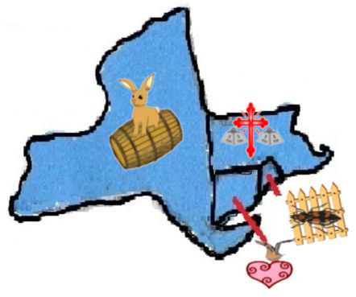 | NY = Albany, New York  CT = Hartford, Connecticut  RI = Providence, Rhode Island  MA = Boston, Massachusetts
